**Chartering Report**

We used the recruiting tool of the subject´s forum. The manager posted an announcement to recruit a new team of members to work for the project. The developers requested applying and the manager approved them, after checking their project objective were like the manager´s, by adding them to the group.

Nieto Córdoba, Pablo / [pabniecor@alum.us.es](mailto:pabniecor@alum.us.es) / 

Román Jiménez, Darío / [darromjim@alum.us.es](mailto:darromjim@alum.us.es) / 

Granado Oliva, Samuel / [samgraoli@alum.us.es](mailto:samgraoli@alum.us.es) / 

Jiménez de la Fuente, Antonio Luis / [antjimde@alum.us.es](mailto:antjimde@alum.us.es) / 

Vela Molina, Alejandro / [alevelmol@alum.us.es](mailto:alevelmol@alum.us.es) / 

As a group, we pledge to collaborate efficiently and work together throughout this subject to meet all the expectations and requirements detailed in the syllabus. We affirm that we have carefully reviewed and understood the syllabus, paying special attention to the evaluation and grading criteria.

Our shared objective is to successfully pass this subject by supporting each other, taking responsibility for our individual tasks, and fostering clear and respectful communication. We are dedicated to completing all assignments, projects, and assessments with honesty and commitment to achieve success in this course.

A team member is considered to be performing well if they complete tasks on time, produce high-quality work, actively collaborate, and receives positive feedback from the team.

On the other hand, a team member is considered to be performing badly if they fail to complete assigned tasks, produce subpar work, show poor communication or collaboration, or receives negative feedback consistently.

Workgroup members who consistently perform well will be acknowledged and rewarded through positive recognition within the team. They also may receive the opportunity to take on leadership roles in upcoming tasks.

Workgroup members who perform poorly will be privately addressed by the team to discuss the reasons for their underperformance. They will be given constructive feedback and a clear plan for improvement. If the underperformance persists, their responsibilities may be reduced, and the lecturer will be informed of the situation if necessary.

A workgroup member may be dismissed from the team if they consistently fail to meet performance expectations despite receiving feedback and opportunities for improvement. Before dismissal, the team will provide a formal warning and an opportunity to address the issues. This decision will be communicated to the lecturer and the pertinent member.

19/02/2025

Signed by: Nieto Córdoba, Pablo

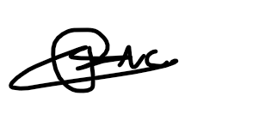

Román Jiménez, Darío

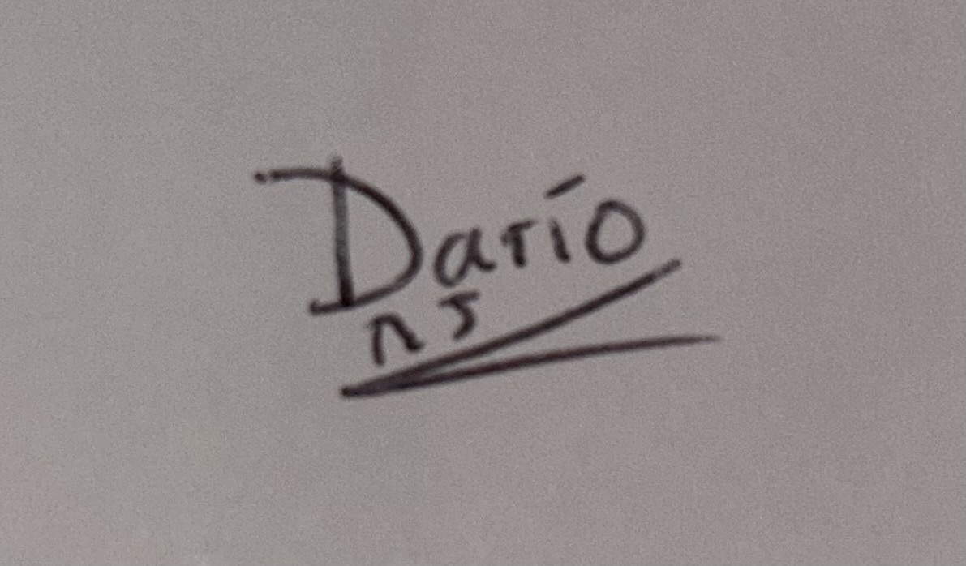

Granado Oliva, Samuel



Jiménez de la Fuente, Antonio Luis



Vela Molina, Alejandro

